Tips for finding and applying for a job
As you learned previously, connecting with security professionals on social media and joining different cybersecurity conferences and organizations are two ways to use your network to find job opportunities. You were also introduced to a few online resources to help you find jobs in the security field. In this reading, you’ll learn about specific sites and resources you can use to apply for jobs.

ZipRecruiter
ZipRecruiter is a popular website for job seekers and employers worldwide; the website helps connect job seekers with available roles in their industry. When you enter the site, you’re asked to fill out specific geographical and work preference questions to help ZipRecruiter match you with opportunities in your field. Then you can upload your resume on the platform and search for jobs in your industry. Employers can reach out to you directly, too, based on your profile and responses.

Indeed
Indeed is another popular website that helps connect job seekers with available roles in their industry. When you first enter the site, search for jobs using the job title, a keyword, or a company that you’re interested in working at. Then, specify your preferred job location. You can also upload your resume on Indeed, which allows recruiters to reach out to you if your resume is a match for a job opportunity.

Monster®
Monster is a frequently used website in both the United States and internationally that helps connect job seekers with available roles in their industry. Similar to the other job search sites, search for a role using the job title, keyword, or company you’re interested in working at, as well as your preferred working location. If you upload your resume to Monster, recruiters might reach out to you if your resume is a match for a job opportunity.

LinkedIn®
LinkedIn® professional services is a social networking site where you can also find jobs in the cybersecurity field. When you first enter LinkedIn®, click on the “jobs” tab. From here, enter the location where you’d want to work and the particular job title that you’d be interested in. LinkedIn is also a great way to learn about a company's culture, values, and even community initiatives. This can help you determine if the company is the right fit for you.
Every technical interview will be different, depending on the company and the interviewers. But here are a few possible technical interview questions to help you prepare:

What is the TCP/IP model?
The TCP/IP model is a framework used to visualize how data is organized and transmitted across a network.
What is the OSI model?
The OSI model stands for open systems interconnection (OSI) model. It is a standardized concept that describes the seven layers computers use to communicate and send data over the network.
What are SIEM tools and what are they used for?
SIEM tools are security information and event management tools that are used by security professionals to identify and analyze security threats, risks, and vulnerabilities.

Situation
The situation is the project you worked on or a challenge that you had to overcome. For example, perhaps you had to manage a disgruntled customer’s negative feedback about your company, a system error on your work device that slowed down a customer transaction, or being left alone in the office for an extended period of time. Fully describing the situation allows the interviewer to gain a clear understanding of the challenge you had to overcome.

Task
The task outlines the key responsibilities or role you played in solving the challenge described in the situation phase of the STAR method. Specifying what the task is provides clarity about what your objectives were in this scenario.

Action
The action describes the exact steps you took to resolve the challenging situation you described in the beginning of the STAR method. The action is crucial to the STAR method because it allows the employer to understand what choices you made to achieve your desired outcome during a real conflict or challenge. Employers want employees who can think fast and make decisions that help solve problems.

Result
Finally, sharing the result of your challenge or example shows the employers how the situation was resolved as a direct result of the actions you took. When participating in an interview, you want to make sure that any example you give with the STAR method ends in a positive result. Positive results show an employer that you are someone who has demonstrated an ability to successfully resolve issues and may lead an employer to offer you a job. Of course, not all situations have completely positive outcomes; if an employer asks you about a situation that didn’t have a positive outcome, try to focus on what you learned from the situation and how that experience helped you become a better employee.

More resources to help you prepare
There’s an endless supply of job-preparation resources available to you. Here are some great ones to get you started:
Interview tips from Google. This resource from the Google Careers team provides best practices and advice on how to prepare and ace your interviews at Google, but of course these tips will work at any company!
Interviewing techniques for persons with disabilities. This resource from the Job Accommodation Network (JAN) offers helpful advice on navigating the interview process for individuals with disabilities.

Prepare for interviews with Interview Warmup
Now that you have developed new skills and knowledge in cybersecurity, it’s time to start preparing for interviews. Interview Warmup is a tool that helps you practice answering questions to become more confident and comfortable throughout the interview process.
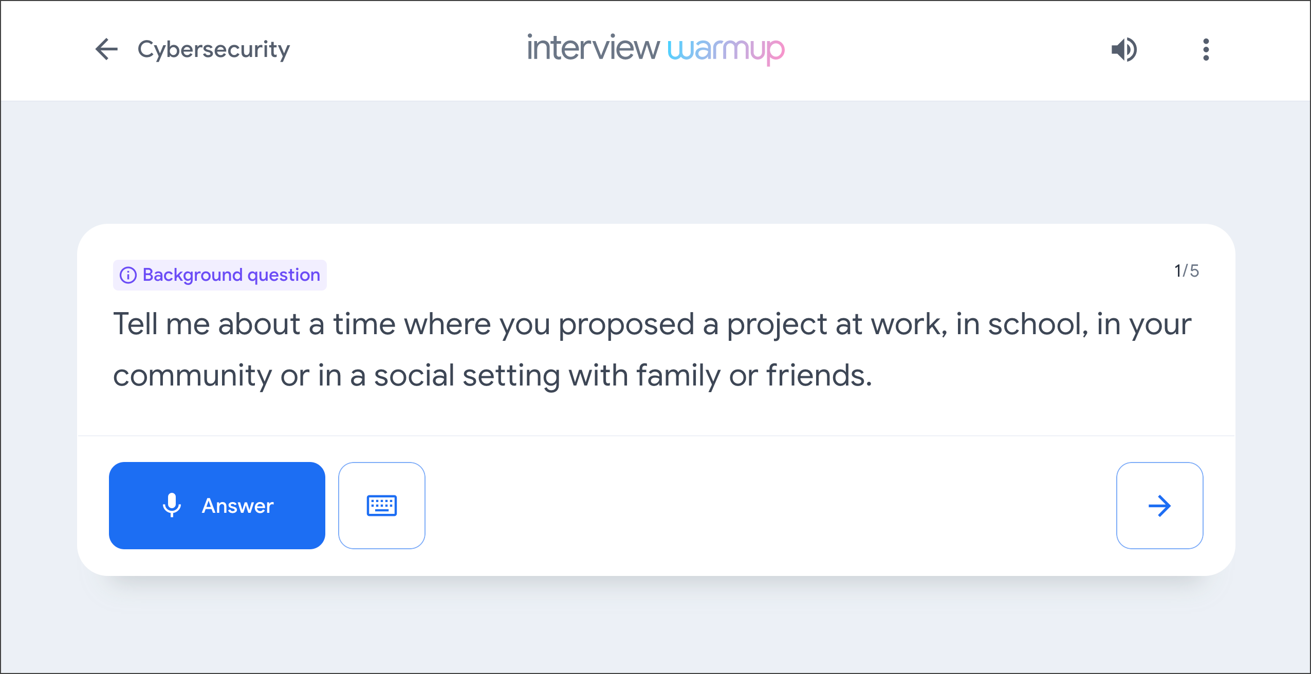

Get started
Follow these steps to start a five-question practice interview related to cybersecurity:
Go to grow.google/certificates/interview-warmup/.
Click Start practicing.
Select Cybersecurity to open an additional menu.
Click Start.
The interview lasts about 10 minutes, and the questions will vary with each attempt. During each interview session, you will be asked two background questions, one behavioral question, and two technical questions. You are encouraged to try as many practice interviews as you want.
You can also review complete lists of cybersecurity interview questions or general interview questions if you'd like to focus on a particular topic.

How it works
Interview Warmup asks you interview questions to practice answering verbally. Your answers will be transcribed in real time, allowing you to review how you responded. In addition, Interview Warmup's machine learning algorithm can detect insights that can help you learn more about your answers and improve the way you communicate.
Here are a few examples of questions Interview Warmup might ask:
What are your career goals for the next five years?
What processes can you use to ensure user data is protected?
Name two types of common cybersecurity attacks?
What are two internal factors that can increase the chances of security risks?
What do security information and event management tools enable security analysts to do?
In Python, what’s the difference between break and continue?
Here are some of the insights that Interview Warmup provides:
Talking points: The tool lets you know which topics you covered in your answer, such as your experience, skills, and goals. You’ll also be able to view other topics that you might want to consider covering.
Most-used words: The tool highlights the words you used most often and suggests synonyms to broaden your word choices.
Job-related terms: The tool highlights the words you used that are related to the role or industry in which you are preparing to work. You’ll also be able to view an entire list of job-related terms that you might want to consider including in your answer.
Interview Warmup gives you the space to practice and prepare for interviews on your own. Your responses will be visible only to you, and they won’t be graded or judged.

